App Concept Summary
A streamlined Uber-style platform where influencers hire nearby creators to capture photos/videos at events. Influencers post a job (time, location, budget); creators accept, meet them, capture content, and upload directly to secure cloud storage—ensuring influencers own all rights. The POC aims to validate this workflow quickly with minimal cost.

1. Objectives for the Meeting
- Align on the vision and target users.
- Define essential Phase 1 (POC) features.
- Review simplified user journeys.
- Confirm timeline, budget expectations, and constraints.
- Establish next steps for proposal and development.

2. Key Discussion Topics

A. Concept Alignment
- Core value and problem solved.
- Influencer vs. Creator roles.
- Pain points addressed.

B. POC Scope
- Must-have features.
- Features for later phases.
- Success criteria for Phase 1.

C. User Journeys
- Influencer: Create job → Receive uploads → Mark complete.
- Creator: View jobs → Accept → Capture → Upload.

D. Technical Approach
- One responsive web app (not two native apps).
- CRUD backend for low-cost, fast delivery.
- Cloud storage for uploads.
- Basic authentication.
- Photo set to waiting
  - Should see all in area
  - QR code for instant
  - Time limit on session

- Payments
  - Platform sets the price
  - Tipping

E. Operational Considerations
- Content rights & minimal legal requirements.
  - Influencer owner rights to image
  - No ownership phototgrapuer

3. Essential Questions
- Who is the initial target user group?
  - Influencers and Photographers
- What features are required vs. optional?
  - Take Pictures
  - Scan QR code
  - Take payment
- Should creators have any temporary file access?
  - Temp access for 1 hours
  - Images Save only
  - Email for payment if they don’t have
- How should payments work during POC?
  - Paypal/Stript payment processing
- Preferred design style or examples?
- Is an LLC already established?

4. POC Recommendation (Cost‑Saving)
- Build one mobile-friendly web app.
- Two user roles in the same system (Influencer, Creator).
- CRUD job creation + acceptance.
- Direct cloud upload flow.
- No maps, tracking, or in-app payments yet.

Recommended Tech Stack
- Frontend: React or Next.js
- Backend: Node.js/Express or Firebase
- Database: PostgreSQL or Firebase
- Storage: AWS S3 / Firebase Storage
- Auth: Firebase Auth
- Hosting: Vercel / Netlify / AWS

5. Reference Wireframes
(Used only to guide discussion.)

Wireframe Set 1
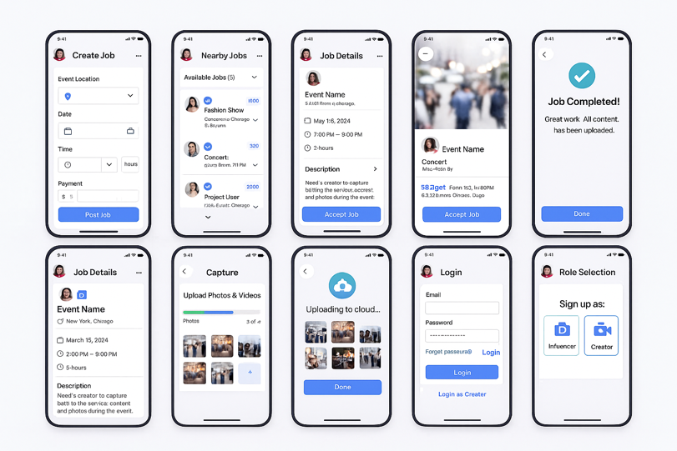

Wireframe Set 2
